==== > **Launch SOAP UI by clicking on the logo from your local machine.**

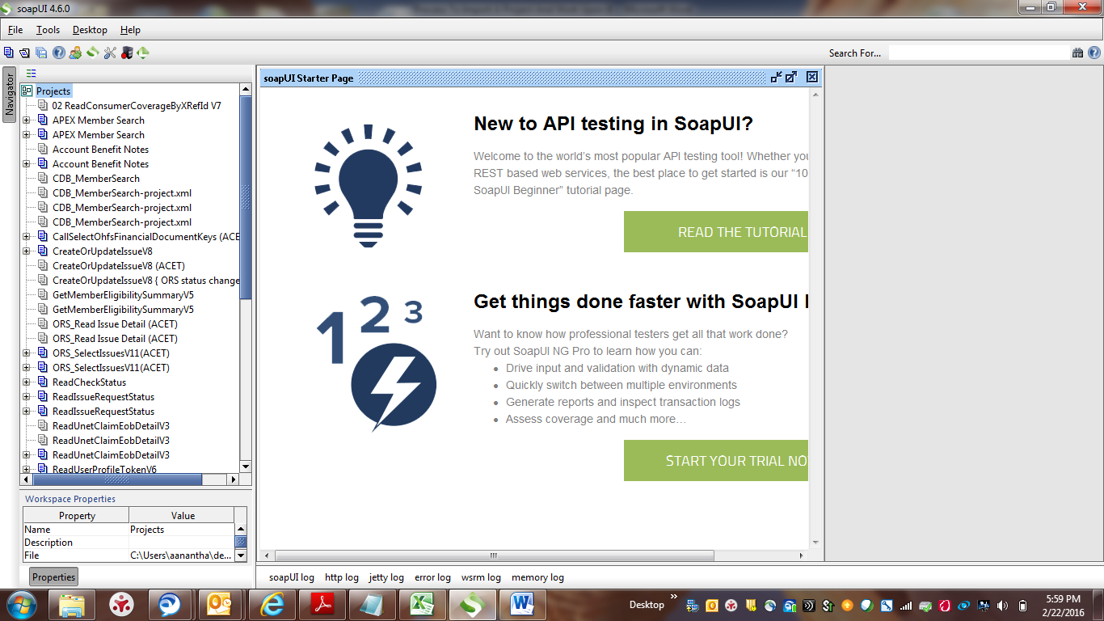

==== > **Click on File.**

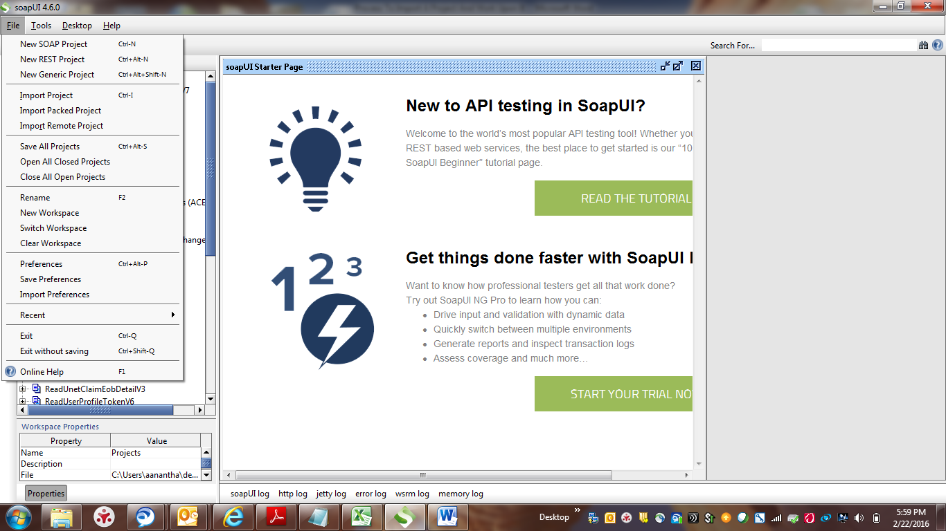

====> **Hover the mouse and Click on Import Project.**

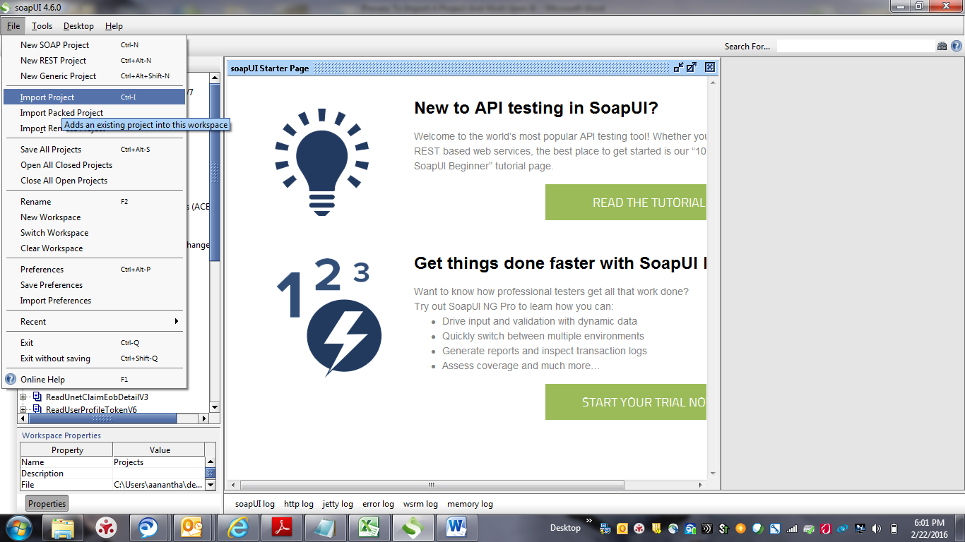

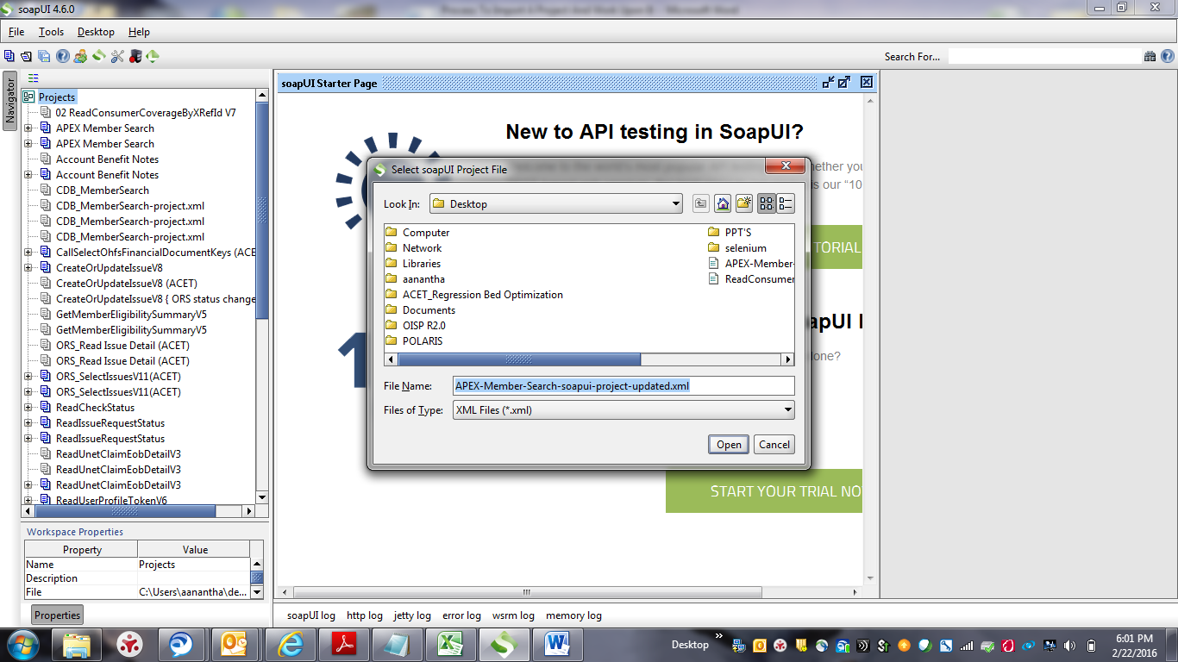

==== > **Select the SOAP project from your machine and click on Open.**

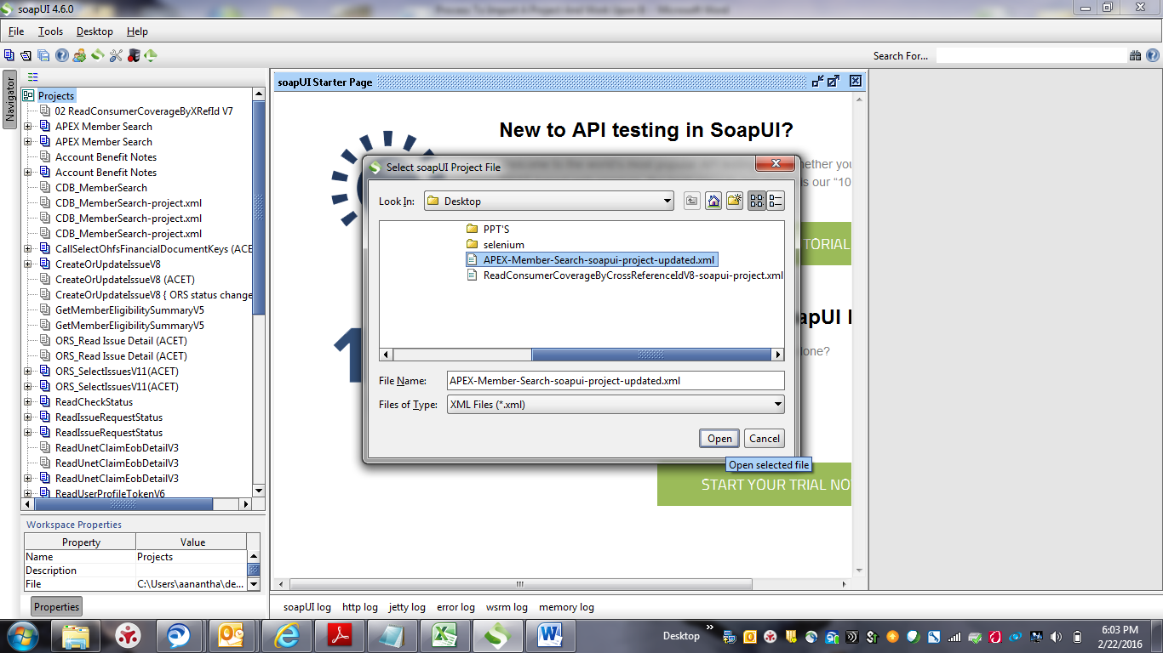

==== > **System will display the selected service/project file on the left side window.**

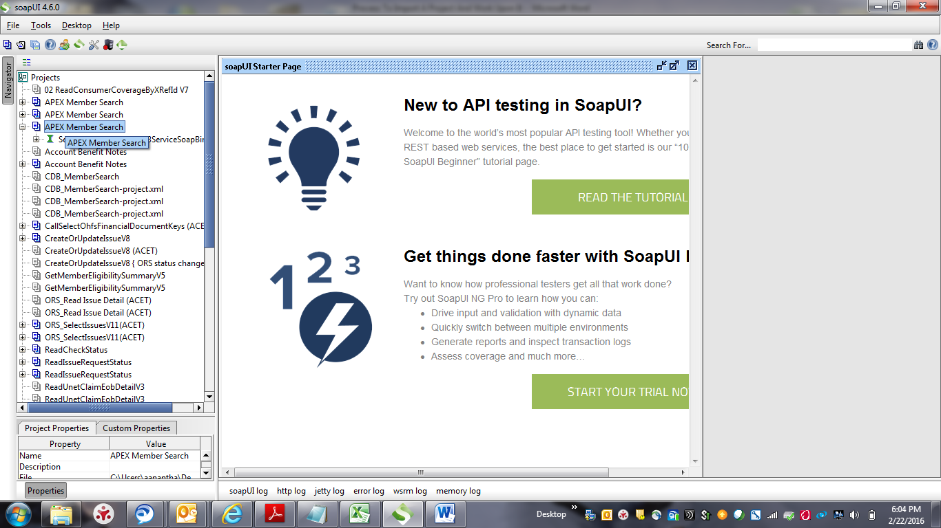

==== > **Expand the “ + ” symbol present under the project file which we have imported. Then system will display the invokePing & invokeService once we expand.**

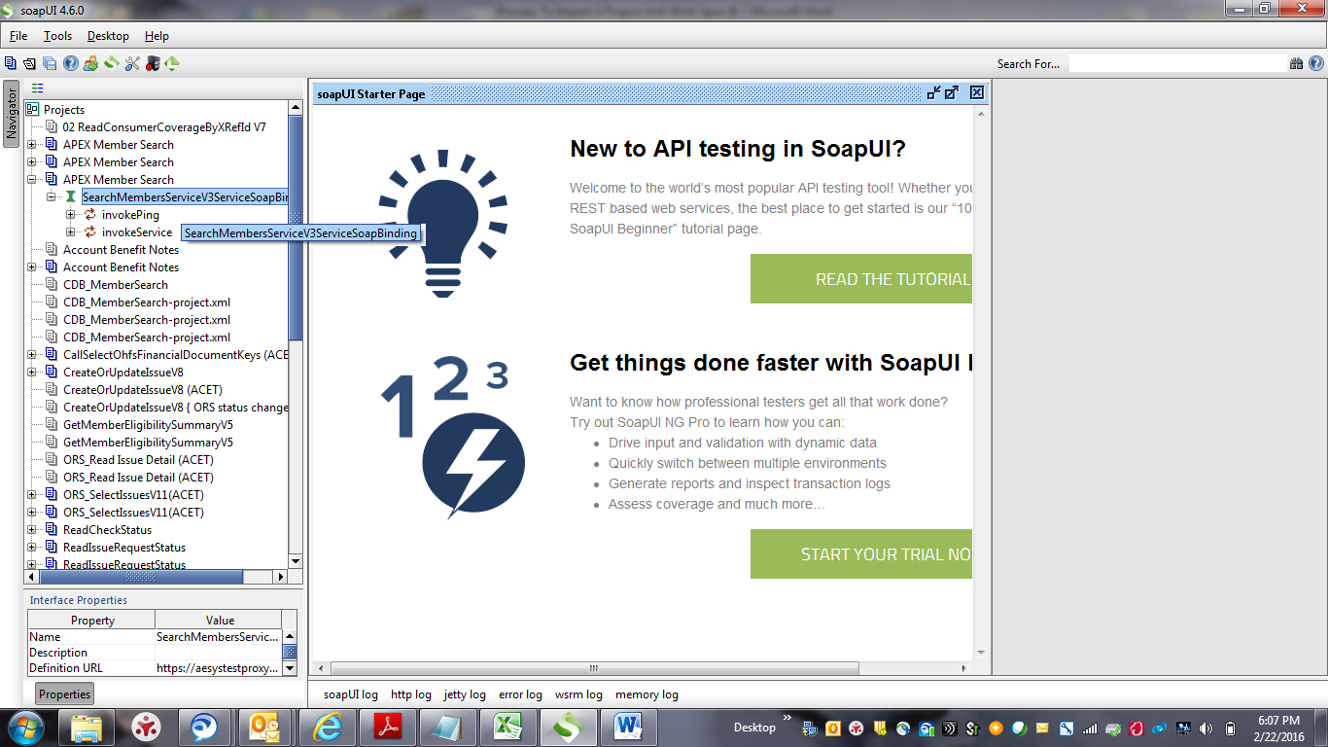

==== > **Expand the “ + “ against invokeService. System will display the Request xml under it.**

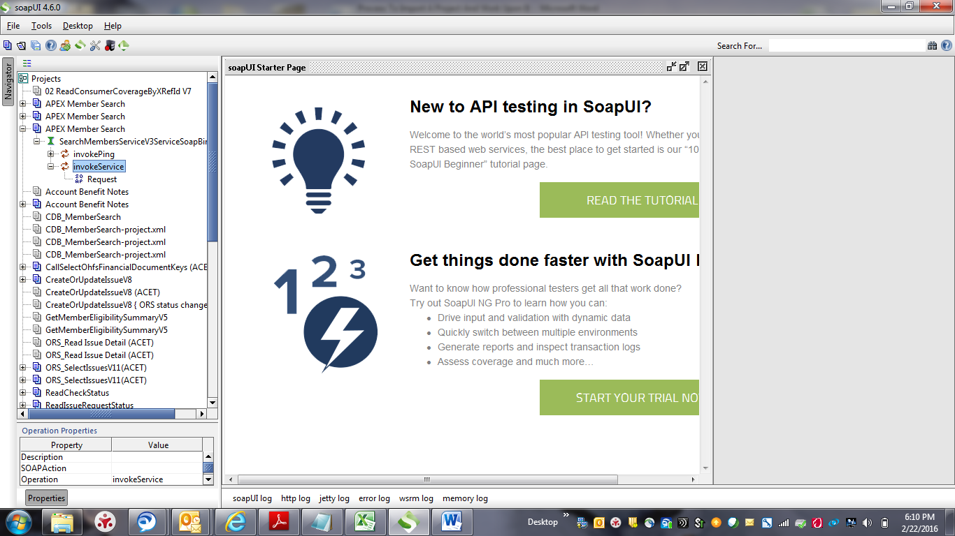

==== > **Double Click on the Request xml. System will display a new Request window on the right side.**

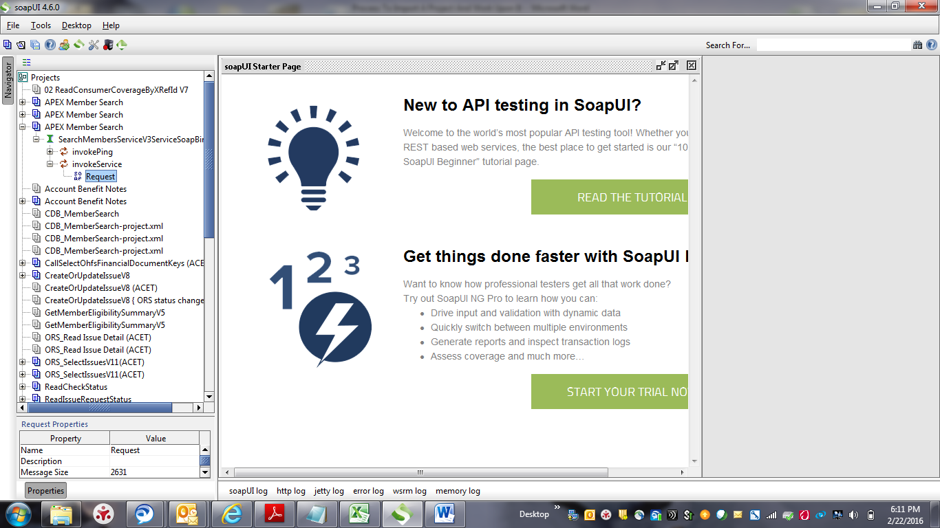

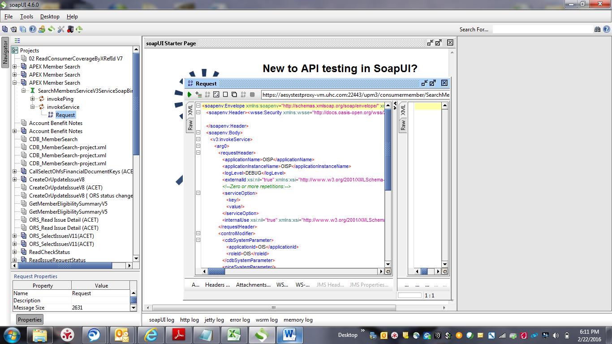

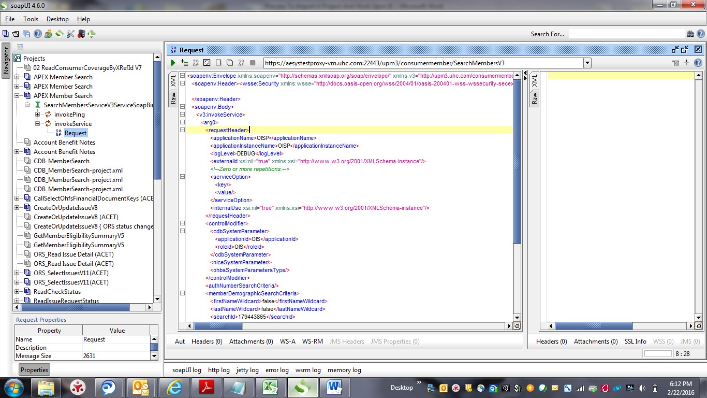

In the above screenshot, in the new window, Left side where we are seeing the xml code is called Request xml.

==== > **Enter all the required parameters in the Request xml .**

==== > **Click on the RUN button ( forward icon ) present on the top left of the request xml. Then system will display the response xml on the right side which is currently empty.**

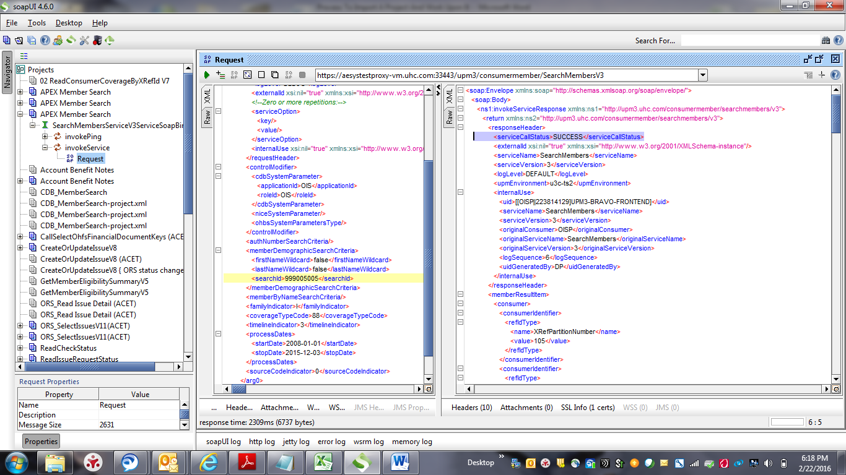

In the above screenshot, on the response xml , we are able to see <serviceCallStatus>**SUCCESS**</serviceCallStatus>which means that the service is working perfectly.

==== > **A scroll bar will be present on the right side of the Response xml. Scroll down and view all the data returned in the Response xml and compare it with Application UI.**